

|  |
| --- |
| **Penetration Testing A Virtual Network**  **David Cox**  CMP210: Penetration Testing  2022/2023 |

*Note that Information contained in this document is for educational purposes.*

Abstract (not more than around 400 words)

The Author of this paper has written it to illustrate and demonstrate their techniques and findings through the course of a Penetration Test against a virtual network consisting of two servers. The aim of this paper is to provide a thorough and well detailed report on the methods used to scan, enumerate and exploit the virtual network and advise on countermeasures to prevent malicious attackers from being able to use these techniques, in a real-life situation.

The tester conducted a penetration test against this network, scanned the network for open ports and services and following additional research, found vulnerabilities on both web servers and successfully exploited those vulnerabilities to gain access to the servers. Once on the servers, the tester forced a remote connection to their machine and changed the administrator password for the network. After gaining full control over the administrator account, the tester then retrieved and cracked password hashes of various users on the network.

On server 1, the tester discovered a variety of open ports including an FTP server allowing for anonymous login, an ArgoSoft web server running on port 80 running on an old version, although the only vulnerability that could be used due to the type of subscription was one that allowed for any user to change any other user’s login details for the mail server. After testing multiple usernames the tester did not uncover any sensitive information and as such moved on. The tester then found another web service running on port 90, which was an outdated content management system known as “Lunar CMS”, the outdated version allowed the tester to exploit an RCE vulnerability and gain access to the server. The contents of server 2 was relatively similar although the webserver on port 90 was instead running an outdated version of “WebID” a service for securing online transactions. The tester was able to bypass file upload restrictions and gain remote access to the server, eventually retrieving domain password hashes and access to 15 accounts.

Contents

1 Introduction 1

1.1 Background 1

1.2 Aim 1

2 Procedure 3

2.1 Overview of Procedure 3

2.2 Procedure 4

2.2.1 Port Scanning 4

2.2.2 Enumeration 5

2.2.3 Exploitation 8

2.2.4 Post-Exploitation 12

Discussion 15

2.3 General Discussion 15

2.4 Countermeasures 16

2.5 Future Work 18

3 Bibliography 19

Appendices 21

Appendix A – Commands & Small Output 21

Appendix B – Large Data Output 24

Appendix C – Other Data 47

# Introduction

## Background

Penetration testing is a core tool used for analysing the security of IT systems (NCSC, 2022). The purpose of a penetration test can be invaluable in reassuring a business, its customers and shareholders that through the procedures carried out through a penetration test that any vulnerabilities in their systems will be found, and effective solutions for mitigating these vulnerabilities and ensuring no risk for any part involved. This can include sensitive information for customers such as payment information, confidential documents for a business including finances or human resource (HR) documents and shareholders, for their involvement in the business. In a recent questionnaire from Beaming and Opinium, UK businesses alone lost close to £13bn due to cybercrime in 2019 and although there had been a general decrease in the average cost per incident down to £6,000 per incident from £26,000 in 2015, the decrease in costs should not be taken within knowing that the amount of incidents occurring has significantly increased from 2015 to 2019. (Irwin, 2020). A graph representing this data can be found at Figure 22.

A network penetration test gives the tester a plethora of tools for use, all with various uses and different outputs and therefore being able to choose the correct tools for the situation to avoid causing any damage to the systems the test is being conducted against, whilst still being able to perform scans to gather information or exploit weaknesses can still occur. A penetration test is often accompanied by a vulnerability assessment which aims to report accurately on any security weaknesses found in an information system (Imperva, 2022), where the vulnerabilities are and explain effective ways of preventing these vulnerabilities from remaining a problem as to help secure the system being tested.

For this penetration test there is a typical company network consisting of two servers. The information that The Author has been given is the IP addresses of each server *192.168.10.1* and *192.168.10.2*. The Author has been asked to conduct a penetration test and demonstrate the risks to the company of a malicious insider and produce a report that highlights the methodology used. A malicious insider is counted as someone who has plugged a machine into the network and can therefore access other devices on the network. The report should also include any information regarding the security of the network, and briefly touch on countermeasures for any vulnerabilities that the penetration tester may have found whilst exploring the network.

## Aim

The aim of this project is to provide a detailed report against a company’s computer network and to report on holes within their security system.

The network that is being tested throughout this report consists of two servers, mentioned through this report as Server 1 (198.168.10.1) and Server 2 (192.168.10.2). It is the penetration testers job to act as if they were a malicious actor and attempt to gain access and exploit the network to gain administrative access. This test has been conducted as if the tester were already inside the network and therefore the assumption can be made that in a real situation, the tester could be replaced with an employee or a malicious actor who has managed to gain access to a device already connected to the company’s network.

This penetration test will be based on a methodology consisting of four steps. The first step is Scanning where the tester will utilise tools to identify services and ports currently open on the network. Enumeration, which is the part of the test where the tester will attempt to uncover further information on the services and ports running on the server, looking for potential attack vectors or otherwise interesting information. Exploitation, the third step in this methodology where the tester begins to attack the system, in an attempt to bypass security measures and gain unauthorised access to a device or account on the network. Post exploitation, the final stage of this methodology where the tester begins to explore the system and search for sensitive information stored on the system.

Once the test has been completed the steps and results that the tester has collected will be shared and discussed throughout this report with the addition of countermeasures and steps to resolve the issues found through the penetration test. This information will also be shared with the company so that they can improve their system security and avoid being at risk to the attacks used in this report, in the future. The tester will also discuss their findings and what steps could have been taken if the tester had more time and resources.

# Procedure

## Overview of Procedure

This penetration test is made up of a series of steps which creates a methodology and procedure that a penetration tester follows. As previously mentioned, the methodology used throughout this penetration test consists of four sections: port scanning, enumeration, exploitation and post-exploitation. Each section has been split up into its own sub-section for the specific parts of the test. Splitting these stages up allows for the tester to go into greater detail upon uncovering important information and provide a higher level of detail as they are able to focus on specific areas in greater depth.

In a standard penetration tester, the methodology would slightly differ from that used in this penetration test with the initial phase often being “Footprinting”. Footprinting is often associated with passive reconnaissance, which involves open-source intelligence (OSINT) and social engineering, although due to the nature of this penetration tester and the assumption that the tester was a malicious actor already inside of the company, this phase is not necessary.

The first step of this penetration test was the scanning phase where the tester ran general scans to ensure the networks within his scope were running and discover basic information about the open ports and services running on those ports. This would be done through a mix of nmap scans and ping requests.

The next step of the test is the enumeration phase. Using the information uncovered from the scanning phase of the test, with general information about the layout and basic information of the network, would then be able to investigate open ports and services in greater detail, more importantly focusing on things such as password policies and taking a general description of the network and adding details to it where possible.

The third step of the penetration test is the exploitation phase. After enumerating the servers and gaining an understanding of what the server consists of, the tester is then able to go about exploiting any vulnerabilities or potential weaknesses they had identified throughout the first two phases of the penetration test. The tester would also be attempting to gain access to a privileged account, in an attempt to gain further control over the server, and potentially the entire network.

Finally, the penetration tester would finish the test after conducting the post-exploitation phase. After successfully exploiting the network vulnerabilities and gaining administrative or “root” access the tester would attempt to retrieve further information and see the limits as to what they would be able to do with their access, potentially trying to gain access to additional accounts in an attempt to strengthen their persistence on the network.

## Procedure

### Port Scanning

As a first step the penetration tester decided to ping both servers to ensure that they were up which they did through the “ping” command which sends packets to the server requesting a response and listens for whether the server provides a response.

**Ping**

Ping is a default package on Windows and Linux systems and utilizes the ICMP protocol to request a response from a given host (Linux Die.net, N/A). Using the ping package and specifying using the “-c 4” flag allowed the penetration tester to choose how many request packets to send to the host. Following the flag up with the IP address of the host the penetration tester is looking to check, they were able to see whether or not a response packet was returned from the host. The penetration tester decided to run this command against both servers to check that they were both up and running before scanning further. The output from these commands can be found in Figure 1-1 and 1-2.

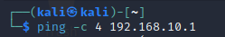

Figure 1: Ping command on Server 1

After pinging both servers to ensure they were up, which they were, the penetration tester decided to run a Nmap scan and identify what services were running and what ports were open, so they could target their enumeration and focus on the appropriate services.

**Nmap**

Nmap is a command-line & GUI utility used for network exploration and security auditing. It contains the functionality to determine whether a host is up, numerous port scanning options, version detection and TCP/IP fingerprinting. (Kali Linux, 2016) For this penetration test two commands were used for each server. Using a kali Linux command line (CLI) each command would use the “-sCV” option. This option is a combination of “-sC” and “-sV”. These switches use default scripts to enumerate the server, and determines service/version information on any port on the server. It also runs with the “-oN” option which is used to save the output to a text file. In some of the scans an additional option is included, “-p-“ which searches ever possible port between 1-65535. This option was chosen in case there was a service running on an obscure or uncommon port. (Nmap, 2022). The outputs from these commands can be found in Figure 2-1 & Figure 3-1.

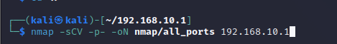

Figure 2: Nmap All Ports Scan Command



Figure 3: Nmap Default Scripts, Host Detection Scan Command

As the penetration tester reviewed the output from these commands, they noticed a HTTP server running on its non-default port, along with an FTP server allowing anonymous logins and various Active Directory ports open, indicating that the servers were a part of an active directory and therefore compromising an account may give them access to both servers. After reviewing the results from the Nmap scans the penetration tester decided to check the status of the email services running on both servers.

**Hping3**

Hping3 is a command-line package that can be used to send custom ICMP, TCP and UDP packets and displays the replies from the server similar to ICMP replies. To establish some basic information about both servers and ensure that they were running, using a kali CLI the penetration tester can craft their command, running the command as the “sudo” user and taking the options “-S”, “-p 53” and “-c 4”. The “-S” option sets a synchronise flag in the packet that is sent, which is used to initiate a TCP connection. Using the “-p 53” option allows us to specify the port that penetration tester is wanting to check. The penetration tester chose to use port 53 due to the fact that from their nmap scans they had noticed that there was a service called “Simple DNS Plus” running on these ports, and assuming that the Hping3 command works, could allow for further scanning and enumeration on these ports, in case of zone transfers or other potential weaknesses.

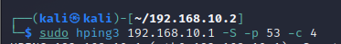

Figure 4: Hping3 Command

### Enumeration

**Polenum**

Polenum is a script used for extracting password policy Information on a windows machine. (Kali Linux, 2022) Since the penetration tester discovered port 445 is open and running a SMB service from their Nmap scan on Server2, they can start to try and enumerate using default credentials. Using the default username “test” and password “test123” they were able to enumerate the password policy information of Server2 using a Kali CLI and executing the command “polenum test:test123@192.168.10.2”. This command calls the polenum package and submits the login information in the format username:password, followed by the server IP that is being queried. The output from this command can be found in Figure 5-1.

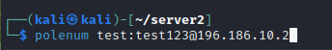

Figure 5: Polenum command

From the output of this command the penetration tester was able to gain a better understanding on the password policies for the domain running on 192.168.10.2. It is also worth noting that there was no password lockout therefore allowing for a potential bruteforce attack.

**Crackmapexec**

Crackmapexec is a package for penetration testing Windows/Active Directory environments. It contains functionality that allows it to enumerate logged in users, making connections through SMB shares to executing other tools (such as MimiKatz) DLL code through Powershell. (Kali Linux, 2022) Crackmapexec is useful for enumerating users, groups and shares. Using a Kali CLI the penetration tester can call the crackmapexec package, specifying that they are wanting to search SMB shares, specifying the IP they are looking to enumerate, followed by the login details for their account and then specifying what they are looking to enumerate. Using the command “crackmapexec smb 192.168.10.2 -u ‘test’ -p ‘test123’ –users” the penetration tester is able to enumerate all users on the machine that it can find and then outputs it in the format of IP, port, network and then username. It also indicates whether the account has incorrect login attempts and when the last unsuccessful login attempt was. (Satran, et al., 2020) The output from this command can be found in Figure 6-1.



Figure 6: Crackmapexec command for users

After reviewing the output from this command, the penetration tester was able to identify a variety of accounts running on both servers, although the usernames on each server were the same. All accounts had no invalid login attempts and were a part of the uadcwnet.com domain.

**Enum4linux**

Enum4linux is a Linux package that can be used for enumerating Windows & Samba Systems. (Kali Linux, 2022). Using a Kali CLI the penetration tester can call the Enum4linux package and specify the “-a” switch, allowing us to conduct all types of “simple enumeration” which covers obtaining a list of users, a list of shares, group lists and member lists. It also enumerates users via RID cycling, retrieving operating system information and conducting an nmblookup. RID cycling is a kind of attack that attempts toe numerate accounts through null sessions taking advantage of the relative ID of a user’s account. This is also paired with the security identifier (SID) that uniquely identifies accounts or groups within a domain. (Wikipedia, 2020) The RID & SID would give us enough information to enumerate the user and retrieve any information such as AD information on the user including any account descriptions, usernames and what groups each user is a part of. (MRL, 2008) The penetration tester can then use the “-u” and “-p” switches to specify the username and password, “test” and “test123” respectively. Then specifying the IP address that the penetration tester is looking to run this scan against allows us to form the command. The output from this command can be found in Figure 7-1.

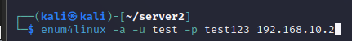

Figure 7: Enum4linux Command

Upon reviewing the output from the enum4linux scan the penetration tester noticed that one user had a password supplied in their description. It was also worth noticing that the login details the user had been using up to this point were a part of a unique group, that no other user was a part of and therefore it may be worth reviewing capabilities to look for methods of privilege escalation when eventually on the server. Finally, that the user that the penetration tester had retrieved a password for, was not a part of the Domain Admins group, and therefore may have less permissions compared to other users on the server, although the penetration tester would be able to target those certain accounts in an attempt for vertical privilege escalation.

**Gobuster**

Gobuster is a tool used to brute-force URLs including directories and files, as well as DNS subdomains. Through the use of a Kali CLI the tester could call the Gobuster package and then specify that they are looking to search for directories with the “dir” option. The penetration tester can then specify the IP using the “-u” flag, since the tester is using an IP address on a different port from the default HTTP port, port 80, the tester then specified the HTTP protocol and the port that the tester was searching on. The tester then specified their wordlist using “-w”. For the use of this penetration test the “common.txt” wordlist was used, which is a part of the dirbuster collection. After specifying the URL and wordlist, the tester then specified the extensions that they were searching for using the “-x” flag. The following file extensions were checked for, “txt, php, css, zip, js”. (Kali Linux, 2022)After specifying the file extensions that the tester wanted to explicitly search for, to reduce the output from the Gobuster scan they also specified what status codes to output. Using the “-s” flag the tester specified HTTP codes; 200, 204, 301, 302 and 307. These status codes represent some kind of positive response that the resource either exists or exists and redirects. Through general exploration of the web server this command was changed with the URL changing to include various subdirectories to further explore the web server. (Harley, 2020).

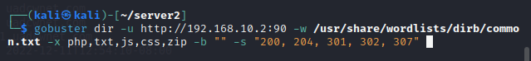

Figure 8: Gobuster Scan on default directory for Server2



Figure 8-1: Gobuster Scan on Docs subdirectory for Server2



Figure 8-2: Gobuster scan on default directory for Server1

After a scan of the default directory of the web server a “docs” subdirectory was found on Server2, upon conducting an additional Gobuster scan on the “docs” subdirectory, revealed a text file which indicated the version of the software running on the web server. The output from these commands can be found in Figure 8-3 and 8-4.

After a scan of the default directory of the web server on Server1, a text file containing the version information of the software running on the web server was found. The output from this Gobuster command can be found in Figure 8-5.

### Exploitation

#### Server 1

**Searchsploit**

After identifying an old install of Lunar CMS from the “license.txt” file found on the webserver. The penetration tester decided to use the Kali Linux package “searchsploit”. Searchsploit is a package used for searching the archive from an exploit database, exploit-db.com. (Kali Linux, 2022). Using the searchsploit package the penetration tester was able to specify their search to find exploits that may be appropriate for the version of Lunar CMS installed. Using the command “searchsploit lunar cms” the penetration tester was able to find all exploits for the Lunar CMS software. The output from this command can be found in Figure 9-1.

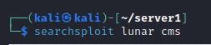

Figure 9: Searchsploit command for finding exploits on Lunar CMS

After looking at the available exploits for Lunar CMS the penetration tester noticed that both exploits were for a later version, meaning that since the CMS was running an earlier version they may be vulnerable to both exploits. The penetration tester decided to review the remote code execution exploit first and analyse how the exploit worked and whether the system may be vulnerable to the exploit. The penetration tester called the exploit to their working directory through the use of the searchsploit package again, using the "-m 33867" flag to specify the exploit ID. The output from this command can be found in Figure 9-3. (Liquidworm, 2014)

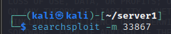

Figure 9-2: Searchsploit command for copying the Lunar CMS RCE exploit

After using a text editor to read through the exploit the penetration tester realized that it was a python2 exploit. The penetration tester noticed this due to the syntax used around print statements. Once the penetration tested had read through the exploit code, the penetration tester realised that they had all of the information required to run the exploit. The exploit required the hostname, path of the Lunar CMS install and path for the file to be uploaded. The penetration tester had the hostname from the beginning of their penetration test (192.168.10.2) and knew that Lunar CMS was running on port 90. They also knew that the content management system (CMS) was installed at the base directory of the web server and they had found the file they were looking to upload. The file that they were looking to upload was a reverse shell, which would generate a connection back to the penetration testers machine, giving them access to the machine. Upon running the exploit, the penetration tester was given a shell on the webserver although was not able to move out of the current directory or perform any kind of lateral movement. What the penetration tester was able to discover was that they were the “NT AUTHORITY/SYSTEM” user. The penetration testers commands and output can be found in Figure 10 & 11.

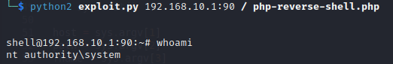

Figure 10: Checking the current user on the tester's shell

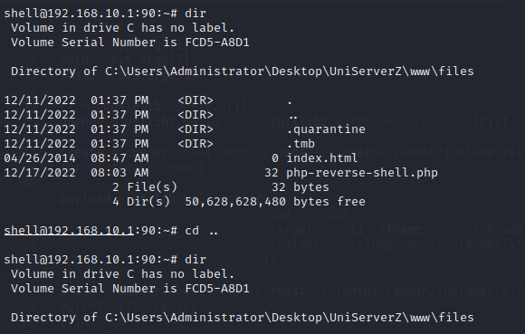

Figure 11: Attempting to move directories on the tester's shell

After the penetration tester had attempted to move around their reverse shell, the penetration tester noticed that they were not able to move directories and were limited to the commands that they could use. The testers first thought was to try and create another reverse shell but this time inside a different process. Since the tester knew they were operating on a Windows machine they would not be able to use Linux based reverse shells, and after checking for certain packages such as Netcat and Python, the tester decided to use a PowerShell reverse shell. After the tester had crafted their reverse shell, they also started a reverse listener on their local Kali machine using the Netcat library. Netcat is a package which is seen as a simple utility which reads and writes data through TCP/UDP networking protocols. To craft their listener, the tester used the following options; “-l” to listen for incoming connections, “-v” for verbose outputting for cutting down on outputs, “-n” specifies that when receiving incoming connections it will not try to resolve the IP through the DNS and “-p” to specify which port to set up the listener on. (Kali Linux, 2022). The commands for the shell and listener can be found in Figure’s 12 & Figure 13.

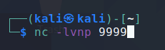

Figure 12: Setting up a Netcat listener

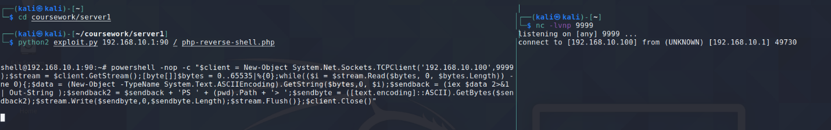

Figure 13: Listener receiving a connection from the server

After gaining a connection from the reverse shell, as shown in Figure 13, the penetration tester tried to execute further commands to identify whether their reverse shell had given them the ability to move throughout the system. They tried to change directories using the “cd” command. After executing the command, they noticed that they were able to move through the filesystem. After identifying that they had greater movement through their reverse shell, the penetration tester then moved on to post-exploitation.

#### Server 2

**Searchsploit**

After identifying a service name and version through a file on the webserver the tester was able to use searchsploit to look for possible exploits. On the webserver there was a file called “changes.txt” in the docs subdirectory. On that file was a list of changes for version 1.1.1 and a link to a changelog of Web ID. Using this information, the tester crafted their command and searched for “webid 1.1.1”. There was only exploit returned from the search, and as such the tester copied the exploit to their working directory and began to analyse the exploit. The command and its output can be shown in Figure 14 and Figure 14-1.

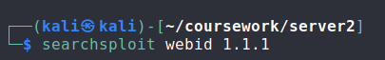

Figure 14: Searchsploit command searching for WebID vulnerabilities

As the penetration tester read through the exploit it became apparent that it was an arbitrary file upload exploit. An arbitrary file upload is an exploit that takes advantage of a web application not validating the file upload type or tricking users to upload malicious files, giving the attackers access to execute malicious code on the server. Looking through the exploit code, it uploads a PHP file called “shell.php” which acts as a reverse shell, allowing the attacker to execute commands on the webserver without authorized access The tester also realized that the exploit was set to only work for webservers running on their default port, port 80, meaning that the exploit would need to be changed for it to work, seeing as the vulnerable webserver was running on port 90. The altered code can be found in Figure 15.

The syntax for the exploit was simple, it required the user to run the exploit using php locally and supply an IP address and base directory for the WebID install. Since the tester had changed the exploit to work on port 90, instead of 80 they were just able to supply the IP address (192.168.10.2) and from their gobuster scans, they knew that WebID was installed at the base of the webserver. The command and its output can be found in Figure 16 & 16-1.

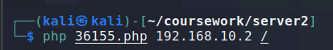

Figure 16: WebID Arbitrary File Upload Command

The tester found that after gaining original access they were in a similar situation to the other server they had exploited that they were unable to move through the file system, and were limited with what commands they could use. As such the tester attempted to use the same reverse shell they had previously used to elevate their shell access. The output from their attempt can be found in Figure 17.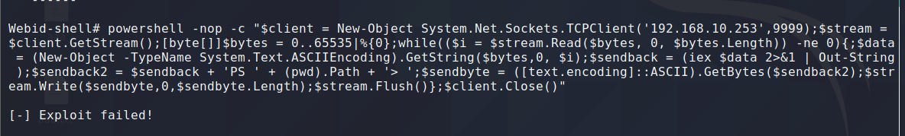

Figure 17: Attempting to use a reverse shell

After the exploit had failed on the tester, they decided to try and use the same exploit, and upon exploiting the system they were greeted with a reverse shell and full access to move around the system. After confirming they were able to move around the system, and checking their user status, which can be found in Figure 18, the tester moved onto post exploitation.

### Post-Exploitation

Since the tester was already the “SYSTEM” user they had full access to the server and due to their previous enumeration, knew what users were on the system and therefore which accounts they could manipulate amongst which was the “Administrator” account.

**Gaining Remote Access**

After performing some research, the tester had found some articles on changing Active Directory user passwords and knew the requirements to perform this step. The tester intended to use the “Set-ADAccountPassword” cmdlet which allows administrators to set a password for a user, computer or service account. They would need to first create a replacement password by creating a variable and using the “ConvertTo-SecureString” cmdlet, as the original cmdlet would not accept string unless converted to secure string. (Microsoft, 2022). Once the tester had conducted their research, they set at changing the password of the administrator account. Their commands can be found in Figure 18.



Figure 18: Changing the Administrator password to allow remote access

Once the tester had changed the password they attempted to log into the server to which they were successful which can be seen in Figure 19.

**Dumping NTLM Hashes**

Once they were on the server, the tester decided to try and install Mimikatz. Mimikatz is a tool that is commonly used to extract sensitive information such as system credentials from the memory. It also has capabilities to bypass multi-factor authentication by reusing stolen credentials, escalate privileges vertically or moving laterally within a network. The tester decided to try and download this piece of software by hosting it on their own machine and downloading it to the server. They started off by hosting a HTTP server in the folder where the executable was stored, and then executing a Powershell command to download and store the file. The tester used the “Invoke-WebRequest” cmdlet to download the file using the “-Uri” option to specify the URL and the “-OutFile” option to specify the location to save the exploit to. These commands and their outputs can be found in Figure 19 & Figure 19-1.

After downloading Mimikatz the tester was able to run the program. The tester started off by running the “log” command so that their output would be stored in a file, allowing for further review later. The tester decided to use the “lsadump” module and then the dcsync command to download all hashes for accounts on the active directory. Seeing as the tester knew the domain name they were able to execute this command and retrieve NTLM hashes for all users. (Administrator, 2018). This command and its output can be found in Figure 20 & 20-1.



Figure 20: Running the lsadump module to retrieve all user hashes on the Active Directory

**Cracking NTLM Hashes**

Once the tester had collected the NTLM hashes for all users on the network, they cleared up the log file so that they were left with just the hashes of the accounts. After that, they then ran “hashcat” on their Kali machine to try and crack these hashes. Hashcat is a password cracker used to try and crack password hashes and reveal the original password. It currently supports over 300 hashing algorithms. (Kali Linux, 2022). The tester knew that they would be using a dictionary attack and therefore would need to use the option “-a” to specify so and after checking hashcat documentation for the correct mode, knew to specify “-m 1000”. The tester also used the “—force” option to ignore precautionary warnings and used the “rockyou” wordlist for bruteforcing the passwords. The command and its output can be found in Figure 21 & 21-1.



Figure 21: Command for Hashcat to crack user passwords

After the hashcat command had finished executing, the tester was given 15 hashes cracked. The tester then decided to check these hashes against the usernames that they were from, a table of which can be found at Table 1.

# Discussion

## General Discussion

The penetration tester was able to go from a position of not knowing the state of the network to full and complete administrative control of both servers within the space of a few hours. Through the methodology mentioned throughout this report the tester was able to identify and show a thorough and complete overview of the network, allowing for anyone with an adequate knowledge of computer systems to gain administrative access over the entire network. This section of the report focuses on the findings and recommendations of the penetration tester with how best to prevent a malicious actor from following in the tester’s footsteps.

Since the tester had been given the privilege of starting their penetration test from a point already on the internal network, there was no need to attempt social engineering or OSINT and therefore removing an aspect from the penetration test that should be a crucial concern for businesses, is the information that can be recovered by interacting with the human element of their brand. Therefore, although this test is accurate in showing vulnerabilities from inside the network, it ignores the impacts that malicious external actors could have on the network.

During the scanning stage of the report the tester ran an Nmap scan against both servers to gain a brief understanding of the open ports and services running on those ports. As the penetration tester reviewed the output from these scans, they could see that on Server 2 there was a SSH server on port 22, DNS server on port 53 and HTTP server on port 90. The SSH and DNS server are running on their regular ports although the HTTP server is running on a non-default port, whilst most websites run on port 80. The tester also noticed that certain sub-directories and files have been hidden by spiders in the robots.txt file with some other default information about the webserver showing in the HTTP headers. There were also some default Active Directory (AD) ports open. Reviewing the scan for Server 1 shows that anonymous login for FTP running on port 21 is open, with some other information included. SSH is also running on port 22 and there is a SMTP mail server running on ports 25 & 79 along with a POP3 server on port 110. There was also a HTTP server running on port 80 and port 90. The web server on port 80 appeared to be related to the SMTP mail server, whilst there is no indication for what the web server on port 90 could be. There is also a Kerberos server on port 88 which was another potential attack vector for the penetration tester.

In the enumeration phase of the penetration test the tester used numerous tools to discover further information about the network and learned crucial information about the password policies for the network. Through the use of the “polenum” package the tester was able to gain information regarding the policies used on the network. Although the policy had some good points such as the minimum password length and not allowing the user to reuse a password if it was within their last 24 passwords, there was no policies for account lockout therefore allowing accounts on the network to be at risk of bruteforce attacks. The tester also noticed in the latter half of their test they would not be logged out, regardless of inactivity and therefore a single instance on the network would be persistent unless the machine was restarted. The tester also made use of the “enum4linux” package which, when used against Server2 gave the penetration tester credentials for a user on the network. The system administrator had stored the user’s password in their Active Directory description which, when retrieved was given to the tester. This is extremely insecure and gave the tester an additional attack vector, and allowed them to execute their other enumeration scripts with these credentials for additional information. The tester was also able to identify domain admins, and therefore focus on gaining control over those accounts later on in their penetration test.

Although the penetration tester used searchsploit to gain access to both servers it is also worth noting that the FTP server allowed for directory traversal and therefore the contents of the filesystem could be read, not just the directory where the FTP server was set up in. The tester was also able to exploit a vulnerability on the webserver running on port 80, for Server 1. The webserver was running an outdated version of ArgoSoft Mail which allowed for any user to alter the login details of users registered on the webserver, allowing for them to bypass any kind of authentication.

Finally, through the post-exploitation stage of this penetration test, the tester noticed that there was no anti-virus or firewall running on either server, therefore allowing for any kind of malicious software to be uploaded to the server without any resistance, and further persistence to be created due to the lack of firewall rules preventing connections from being setup and as such, connections to be transferred at the actors will. Overall the tester believes that through their methodology they were able to fairly conduct and provide a detailed and well-rounded report against the network within their scope and has followed their intended methodology correctly, implementing it to its fullest at every step.

## Countermeasures

Throughout the test, the tester noted numerous vulnerabilities or misconfigurations that allowed for unintended access to malicious actors, therefore allowing multiple attack vectors and a plethora of issues for the company in question.

First of all, the tester would advise the company to set up firewalls and antivirus software across all devices on the network. By implementing a firewall and configuring rulesets for that firewall, a majority of the tools used throughout this penetration test would either become obsolete, or return fewer results giving the tester less information to work with. The author of Nmap mentions blocking and slowing down Nmap scans to discourage malicious actors or prevent them from uncovering information about a target. The author mentions implementing a “deny-by-default” rule which essentially denies all traffic, and then overrides the initial denial for traffic that is seen as essential. Due to the way that Nmap is made, a port not returning a packet to confirm whether it is open or closed but rather “filtered” takes significantly longer to get a response and therefore increases the scan time (Lyon, 2009). For larger scans over large amounts of ports or servers, this could increase the scan time and therefore slow down attackers, allowing for the scans to be completely stopped by a company’s security operations center (SOC). Anti-virus software would also be advised onto the company’s machines as this would be an additional method to prevent malicious code from being uploaded to the machines, in the example of this penetration test, the tester used “mimikatz” a piece of software that, although not malicious, would be flagged by an antivirus and therefore not allowed to run.

From the testers enumeration phase they also discovered a misconfigured FTP server, which allowed for directory traversal. Due to this misconfiguration a malicious actor is able to move around the filesystem of the server without needing any credentials. This misconfiguration could be changing the file permissions for utilising commands that list or read files such as “ls” with the path “../”. Using the path “../” indicates that the user is checking in the folder before their working directory, and by changing the user’s permissions to make it unreadable in the previous directory would prevent this attack from being utilised. This misconfiguration could also be solved by disabling anonymous logins as it may just be the anonymous user that has access to read files at various points on the filesystem and therefore creating for alternative solutions to the problem. Disabling anonymous logins would also prevent from anyone being able to connect to the FTP server without an account. The tester also discovered multiple unprotected shares, that they were able to search through and download. Shares can potentially contain sensitive information and therefore leaving them open for anyone on a network to access is bad policy. A simple solution for this could be requiring users to re-authenticate when accessing a share to ensure that, even if a computer was compromised, information stored on shares may not be.

Furthermore, in the enumeration phase of the penetration test the tester noticed multiple outdated web services including outdated ArgoSoft mail services, outdated Lunar CMS & outdated WebID configurations. Outdated configurations leave a server vulnerable to countless exploits and large amounts of legal trouble. The exploits used for both servers worked due to the outdated versions of the software being ran on the webservers, and therefore the next countermeasure that the company could take to prevent attacks such as those shown in this report, could be to regularly check for updates on all services. Although web services were this company’s weakness, any of the services being ran on their network could leave them at risk of a breach, and therefore making it imperative to keep all software up to date.

Finally, during the enumeration & post-exploitation phase of the report the tester noticed that sensitive information such as user passwords had been stored in their account description, therefore meaning any user could find the password for these accounts. Descriptions for accounts on an AD network are visible to everyone and therefore sensitive information should not be stored in these fields. If an employee were to go rogue within the company, they would be able to impersonate other users and potentially gain access to documents that, with their own account, they would not be able to access therefore putting the company at risk of suffering from a greater breach, and potentially legal trouble. The tester also noted weak password policies and would therefore suggest multiple changes to the company’s policy in an attempt to strengthen password security, the first of which would be a change in maximum password age, reducing it from 134 days to 30. Requiring password changes every month, although annoying for users, is a security method that means that if a malicious actor had gotten access to an account, they would not have persistence for an extended period of time and therefore providing a more secure system. The next change to the password policy that the tester would recommend is setting up a lockout threshold. The current password policy does not have a lockout threshold therefore allowing users to continue trying passwords until they get the correct password, meaning that a bruteforce attack would be viable to get into the accounts on this network. The final change that the tester would recommend altering is the policy around complexity requirements. Current password complexity does not have requirements, meaning that a password can consist of whatever the user chooses, and will often not include special characters which, when mixed with other characters can create a secure password. Therefore, the tester would recommend requiring passwords to include at least one special character, one number and one uppercase and lowercase number.

## Future Work

The tester believes that if given more time and resources they could have explored other routes of attack against the server such as Denial of Service (DOS) attacks or phishing. Given the scope of the test, the tester was not required to perform any kind of phishing or social engineering although feels that if given the opportunity believes it would be an important factor to consider in future penetration tests. The human factor of a company is one that cannot be simulated or expected and therefore being able to test likely scenarios would help the tester suggest methods of protecting the company from things that may not have been covered in this report, or suggest ways of being prepared for when things do go wrong. Some of the methods the tester could have used to test for phishing could include through emails sending emails to employees in the attempt of getting them to click the link and as such, handing over credentials or other potentially sensitive information. Attacks such as DOS would require more resources then the tester had access to, to simulate a realistic attack, and once again another attack vector that malicious actors may decide to use.

# Bibliography

Administrator, 2018. *Dumping Domain Password Hashes.* [Online]   
Available at: https://pentestlab.blog/2018/07/04/dumping-domain-password-hashes/  
[Accessed 14 1 2023].

Harley, 2020. *Dealing w/ Gobuster “WildCard” and “Status Code” Errors.* [Online]   
Available at: https://infinitelogins.com/2020/09/05/dealing-gobuster-wildcard-and-status-code-errors/  
[Accessed 11 12 2022].

Imperva, 2022. *Imperva.* [Online]   
Available at: https://www.imperva.com/learn/application-security/vulnerability-assessment/#:~:text=A%20vulnerability%20assessment%20is%20a,mitigation,%20if%20and%20whenever%20needed.  
[Accessed 3 12 2022].

Irwin, L., 2020. *UK cyber crime rate has doubled in the past five years.* [Online]   
Available at: https://www.itgovernance.co.uk/blog/uk-cyber-crime-rate-has-doubled-in-the-past-five-years  
[Accessed 15 1 2023].

Kali Linux, 2016. *Tool Documentation.* [Online]   
Available at: https://www.kali.org/tools/nmap/  
[Accessed 3 12 2022].

Kali Linux, 2022. *Crackmapexec.* [Online]   
Available at: https://www.kali.org/tools/crackmapexec/  
[Accessed 9 12 2022].

Kali Linux, 2022. *Enum4linux.* [Online]   
Available at: https://www.kali.org/tools/enum4linux/  
[Accessed 10 12 2022].

Kali Linux, 2022. *ExploitDB.* [Online]   
Available at: https://www.kali.org/tools/exploitdb/  
[Accessed 17 12 2022].

Kali Linux, 2022. *Gobuster.* [Online]   
Available at: https://www.kali.org/tools/gobuster/  
[Accessed 11 12 2022].

Kali Linux, 2022. *Hashcat.* [Online]   
Available at: https://www.kali.org/tools/hashcat/  
[Accessed 14 1 2023].

Kali Linux, 2022. *Nmap Tool Usage.* [Online]   
Available at: https://www.kali.org/tools/nmap/#ncat-1  
[Accessed 1 11 23].

Kali Linux, 2022. *Polenum.* [Online]   
Available at: https://www.kali.org/tools/polenum/  
[Accessed 9 12 2022].

Linux Die.net, N/A. *ping - Linux manual page.* [Online]   
Available at: https://linux.die.net/man/8/ping  
[Accessed 17 12 2022].

Liquidworm, 2014. *Lunar CMS 3.3 - Remote Command Execution.* [Online]   
Available at: https://www.exploit-db.com/exploits/33867  
[Accessed 17 12 2022].

Lyon, G., 2009. *Block and Slow Nmap with Firewalls.* [Online]   
Available at: https://nmap.org/book/nmap-defenses-firewalls.html  
[Accessed 1 16 2023].

Lyon, G., N/A. *Block and Slow Nmap with Firewalls.* [Online]   
Available at: https://nmap.org/book/nmap-defenses-firewalls.html  
[Accessed 16 1 2023].

Microsoft, 2022. *Set-ADAccountPassword.* [Online]   
Available at: https://learn.microsoft.com/en-us/powershell/module/activedirectory/set-adaccountpassword?view=windowsserver2022-ps  
[Accessed 14 1 2023].

MRL, 2008. *Enum4linux.* [Online]   
Available at: https://labs.portcullis.co.uk/tools/enum4linux/  
[Accessed 10 12 2022].

NCSC, 2022. *Advice on how to get the most from penetration testing.* [Online]   
Available at: https://www.ncsc.gov.uk/guidance/penetration-testing  
[Accessed 3 December 2022].

Nmap, 2022. *Nmap Scripting Engine.* [Online]   
Available at: https://nmap.org/book/nse-usage.html  
[Accessed 3 12 2022].

Satran, M., Batchelor, D. & Ashcraft, A., 2020. *Bad-Pwd-Count attribute.* [Online]   
Available at: https://learn.microsoft.com/en-us/windows/win32/adschema/a-badpwdcount  
[Accessed 9 12 2022].

Wikipedia, 2020. *Relative Identifer.* [Online]   
Available at: https://en.wikipedia.org/wiki/Relative_identifier  
[Accessed 10 12 2022].

# Appendices

## Appendix A – Commands & Small Output

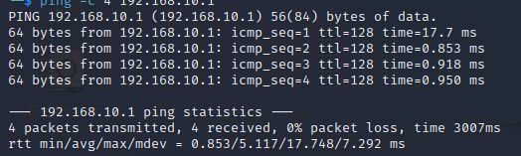

Figure 1-1: Output from ping command for Server1

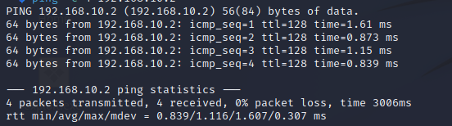

Figure 1-2: Output from ping command for Server2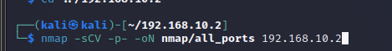

Figure 3-1: Default scripts, version detection, searching all ports nmap scan command

Figure 9-1: Output from searchsploit command for Lunar CMS

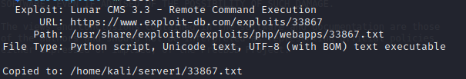

Figure 9-2: Output from searchsploit command for copying the exploit for Lunar CMS



Figure 14-1: Output from searchsploit command for WebID

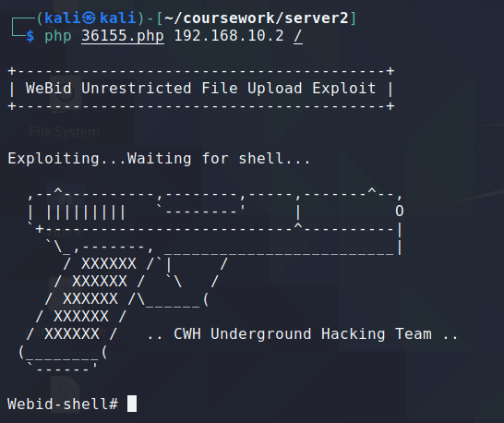

Figure 16-1: Output from WebID Arbitrary File Upload Exploit

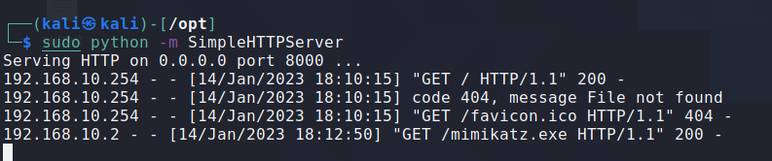

Figure 19: Starting a web server and receiving a connection for the mimikatz file

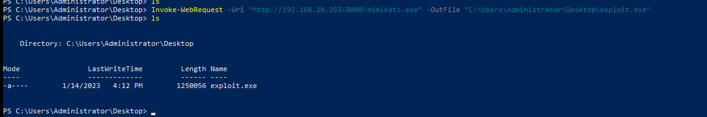

Figure 19-1: Downloading the mimikatz file and storing it onto the local machine, also showing that it has downloaded successfully

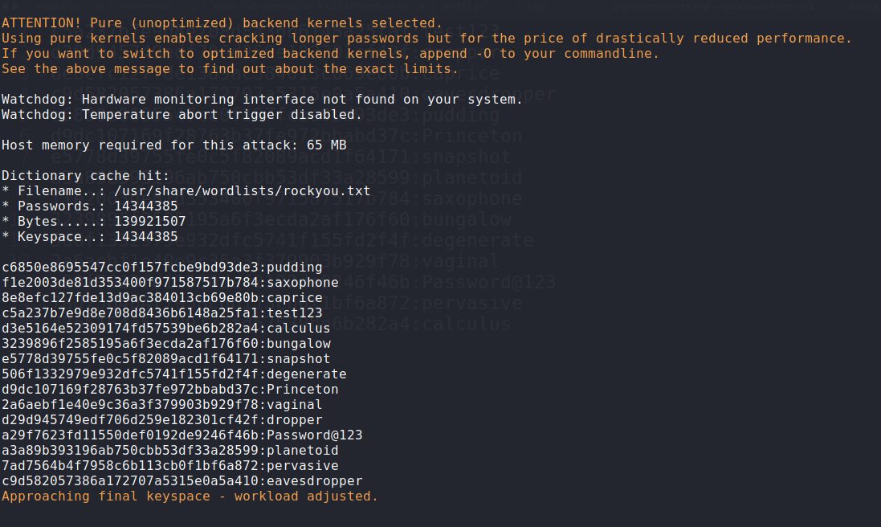

Figure 21-1: Output from the Hashcat command

## Appendix B – Large Data Output

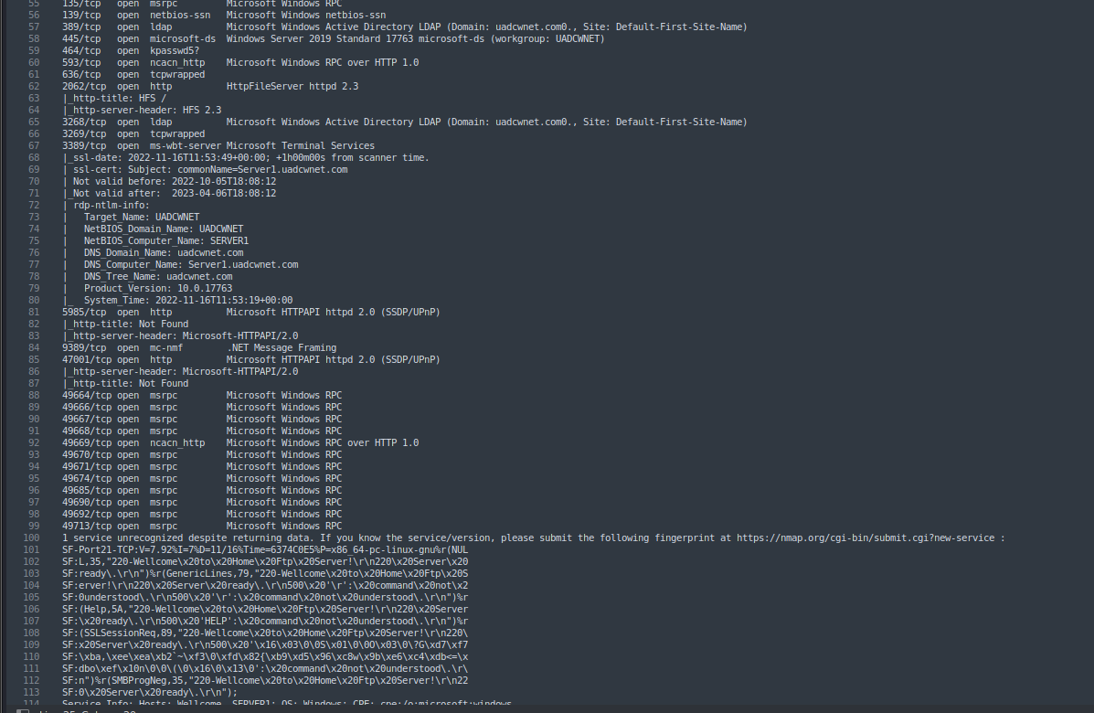

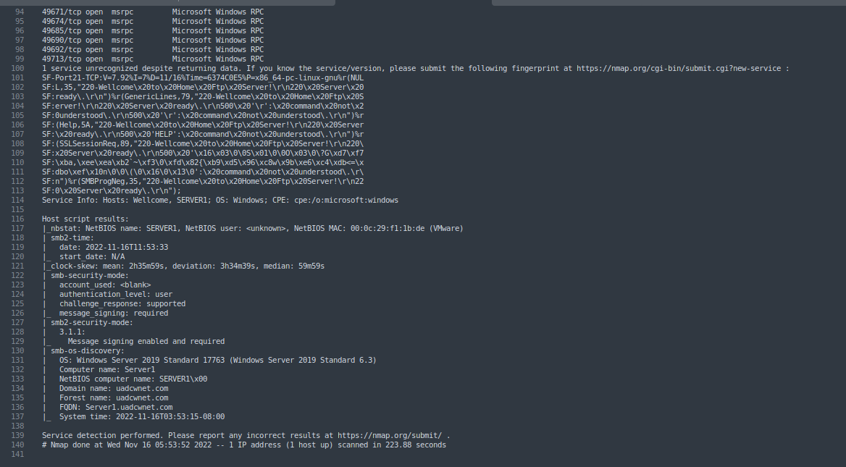

Figure 2-1 Nmap Scan result for 192.168.10.1

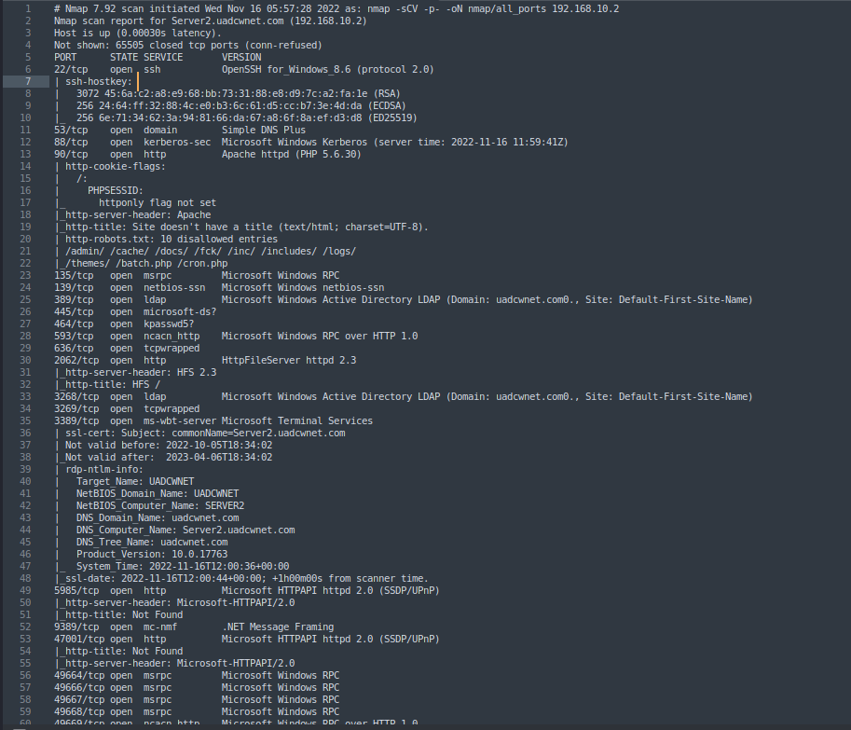

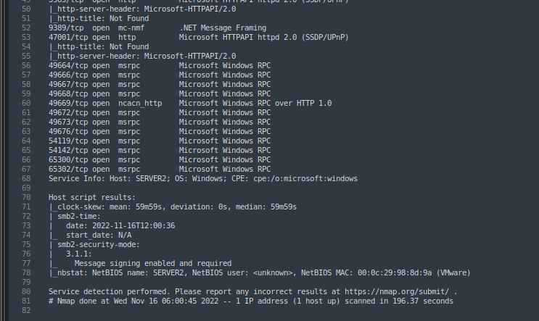

Figure 3-2: Nmap scan result for 192.168.10.2

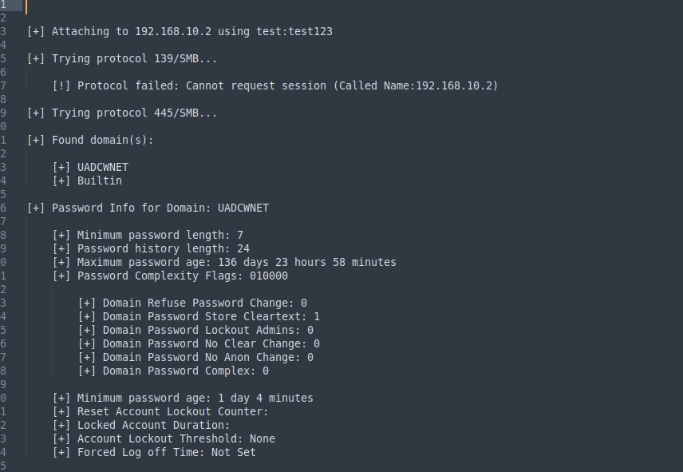

Figure 5-1: Polenum Output

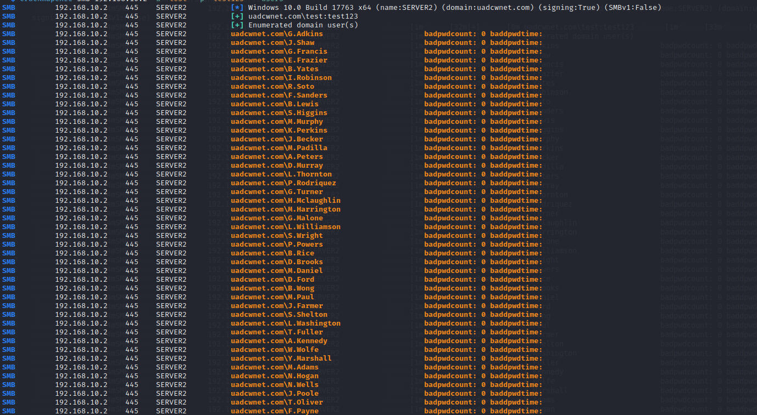

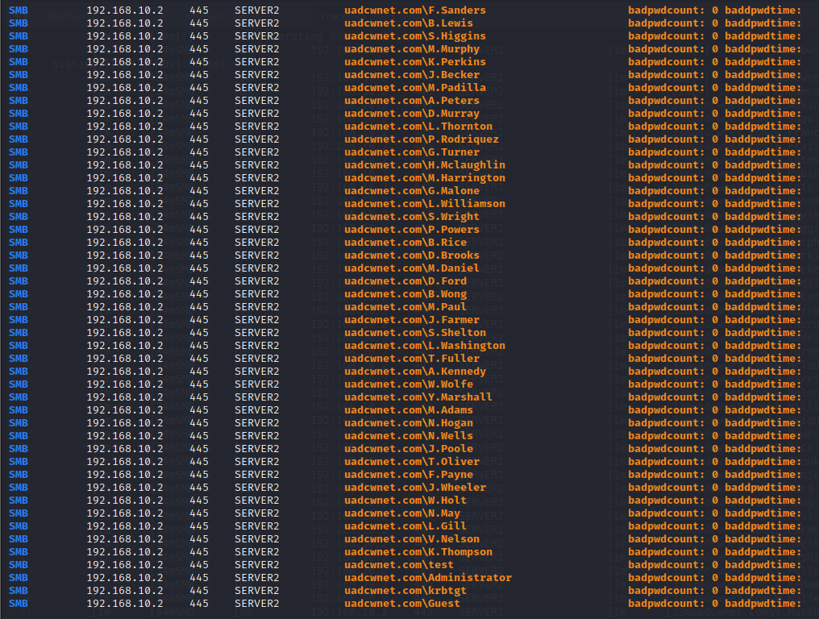

Figure 6-1: Crackmapexec Output

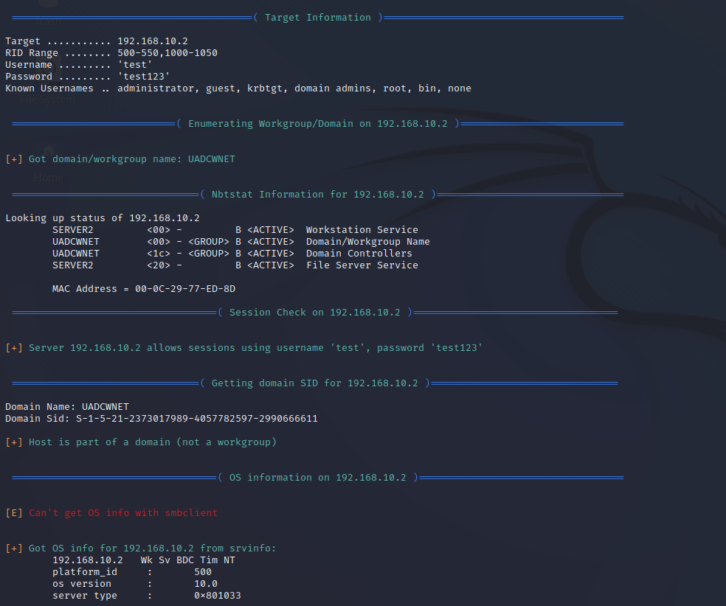

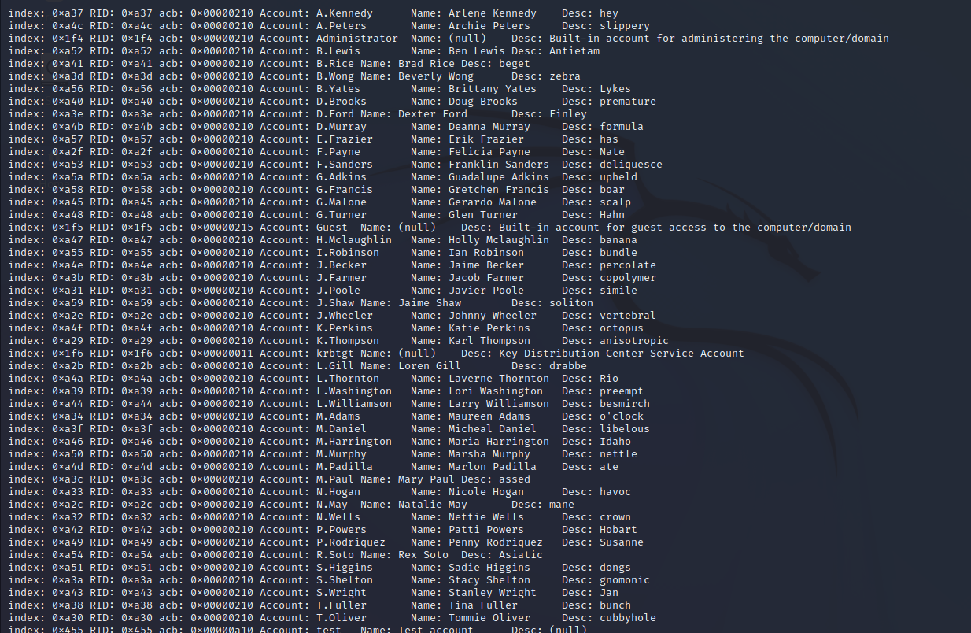

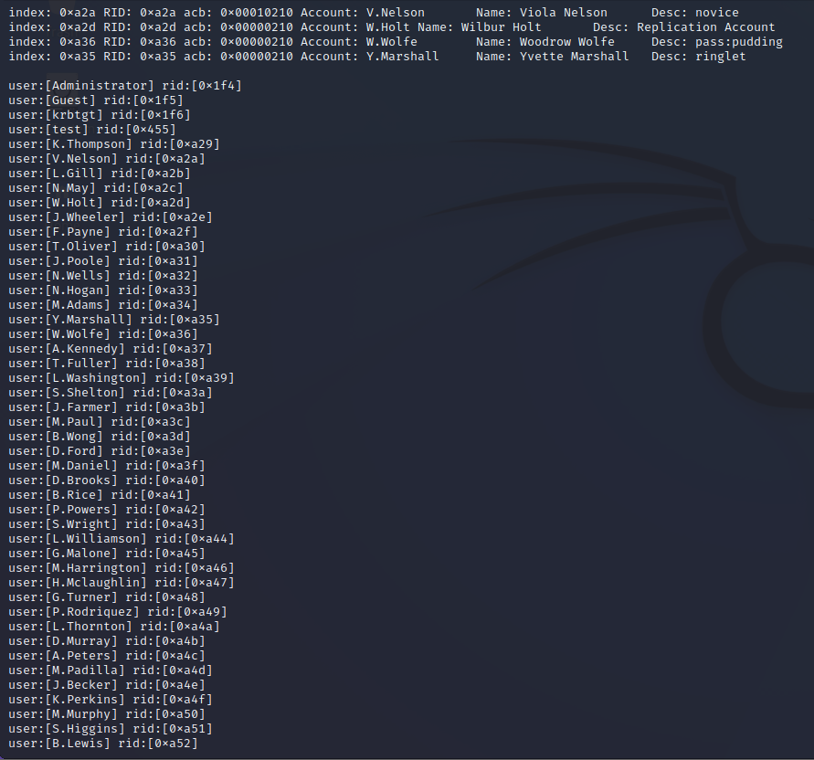

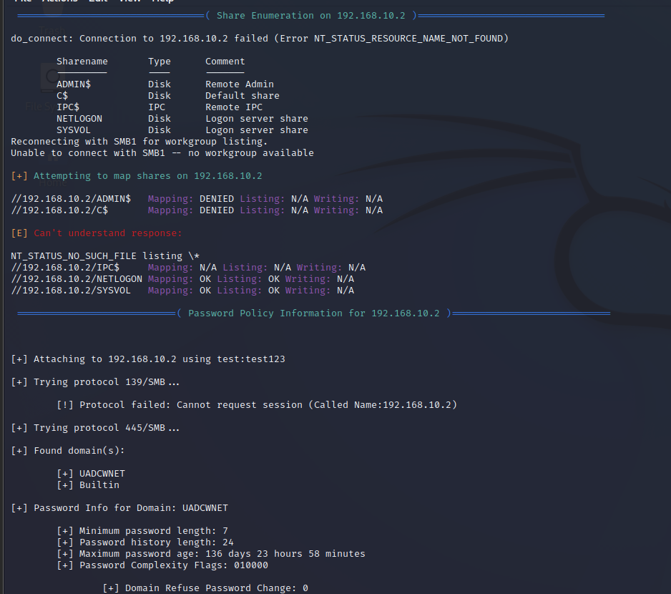

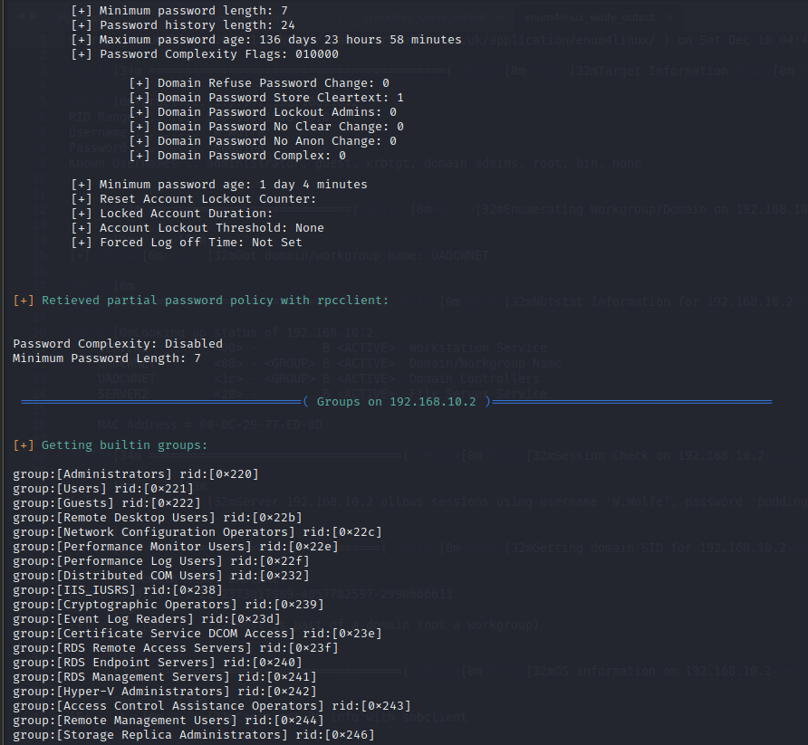

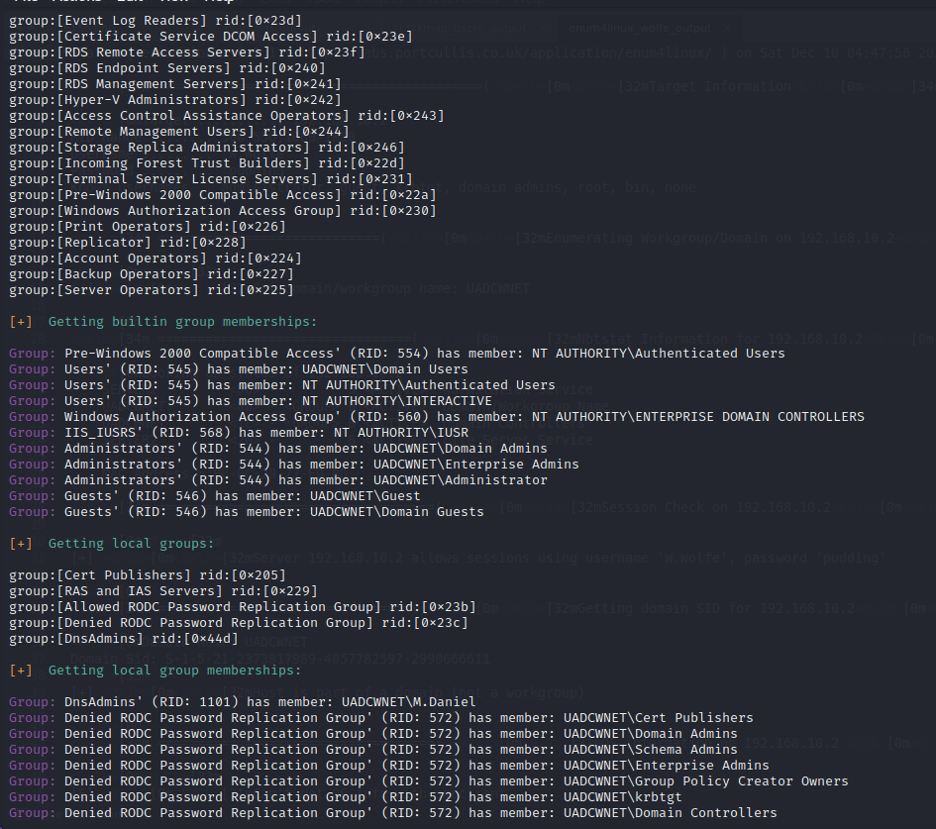

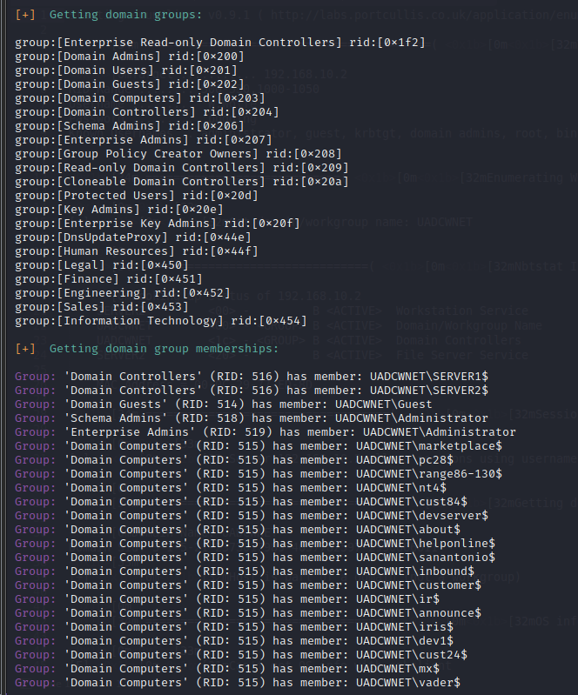

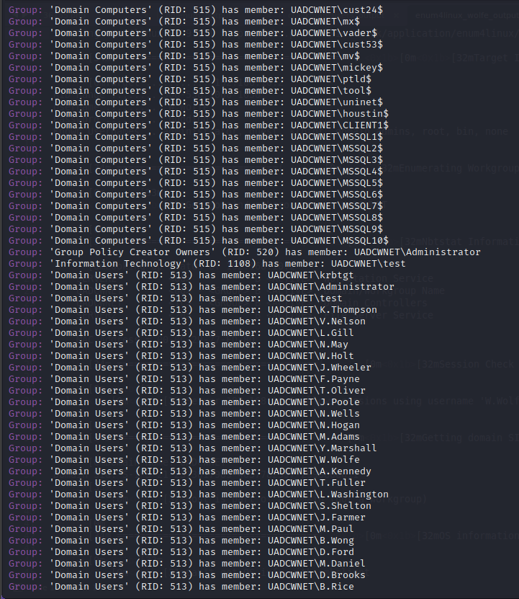

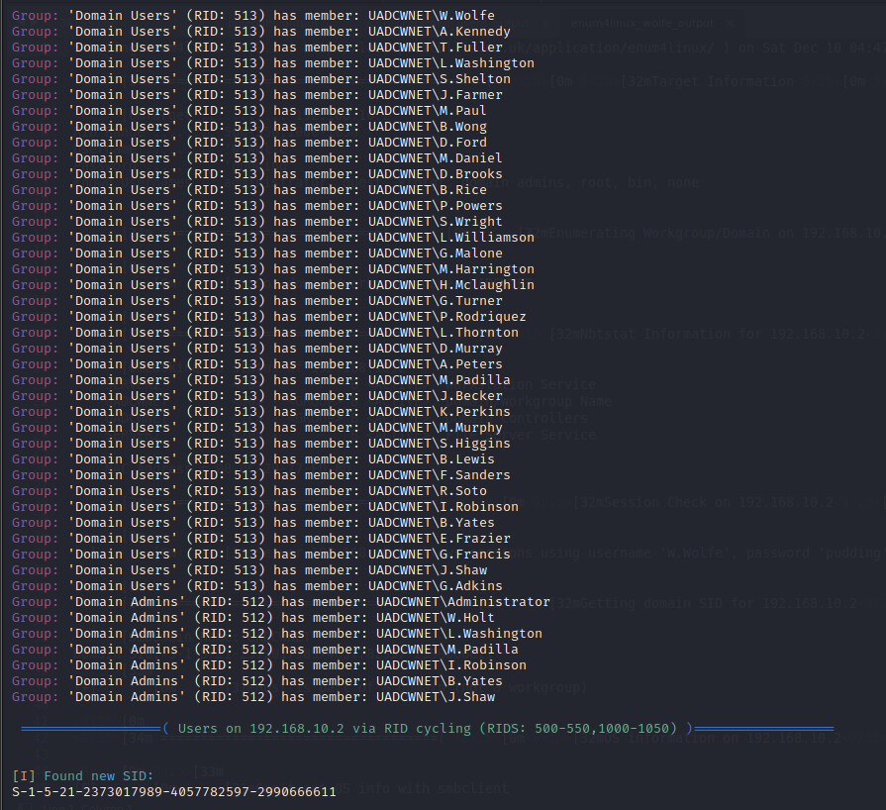

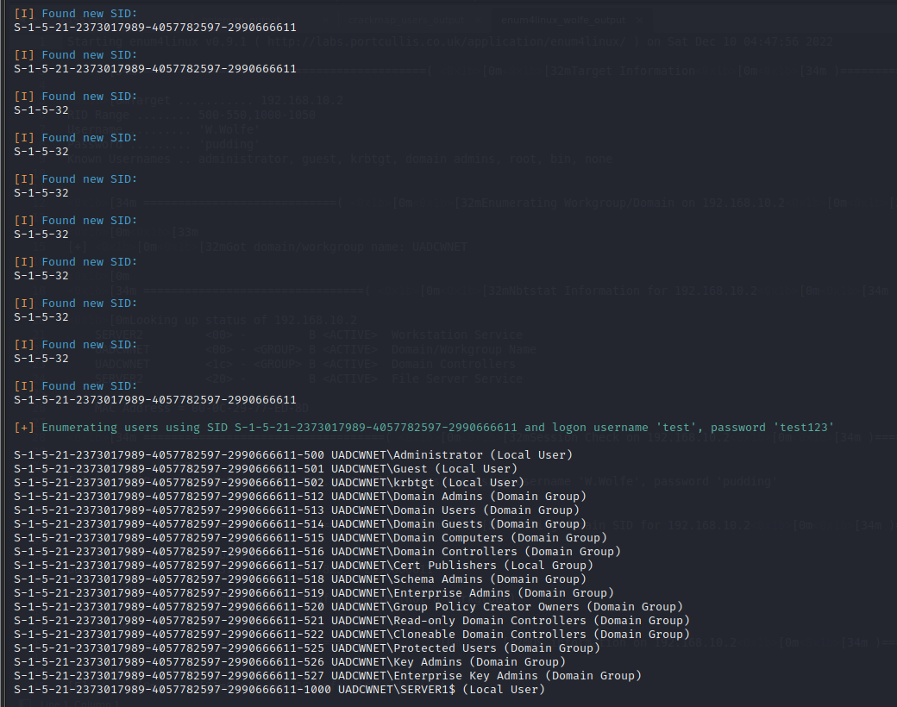

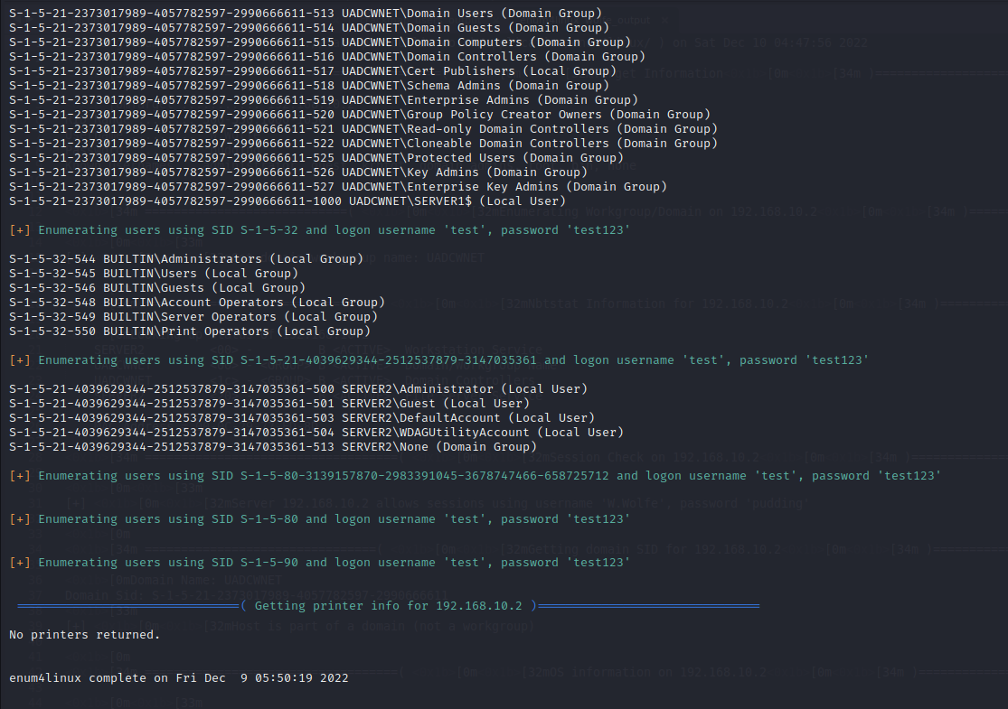

Figure 7-1: Enum4linux Output

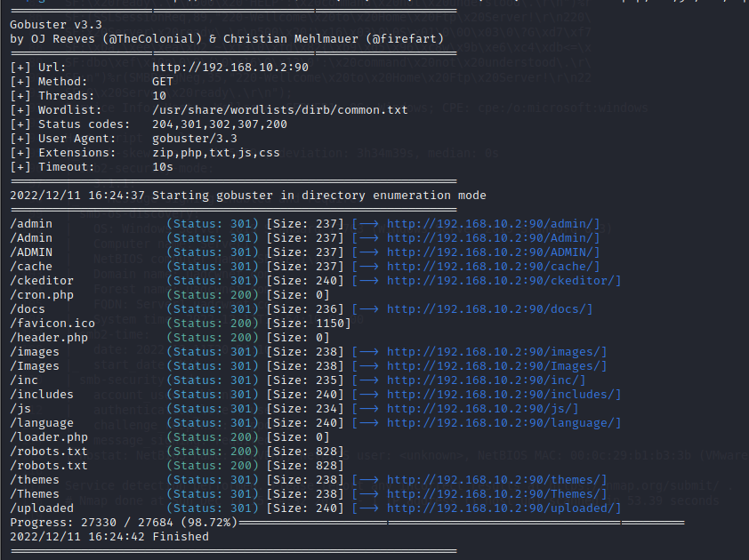

Figure 8-3: Gobuster Default scan results for Server2

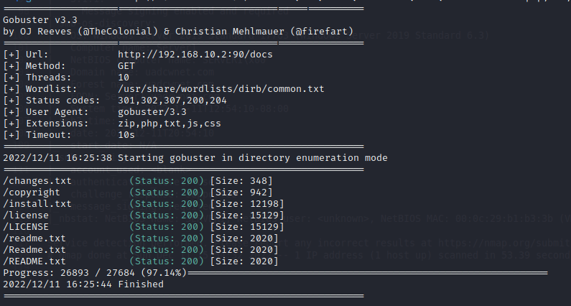

Figure 8-4: Gobuster Docs scan results for Server2

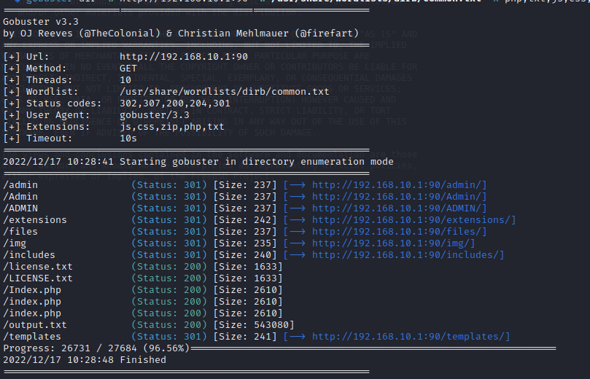

Figure 8-5: Gobuster Default Scan results for Server1

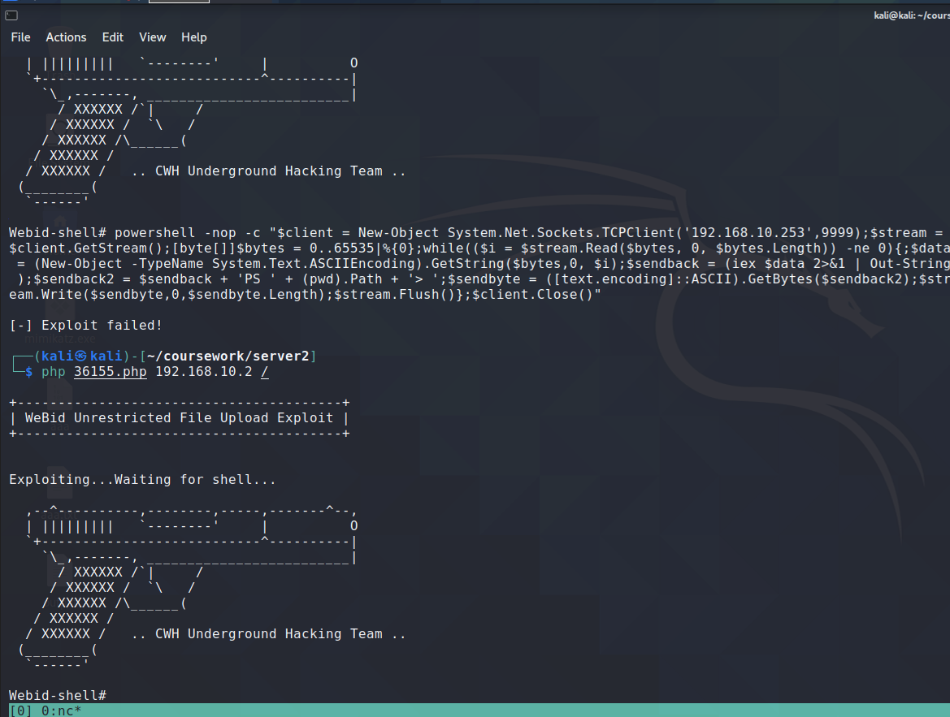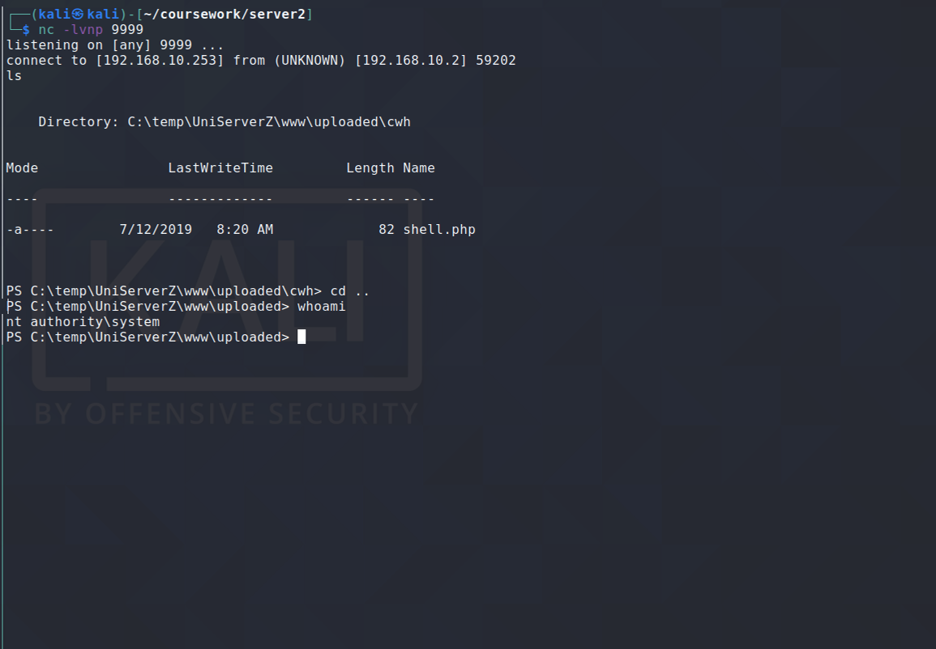

Figure 18: Checking privileges and gaining a reverse shell on the machine

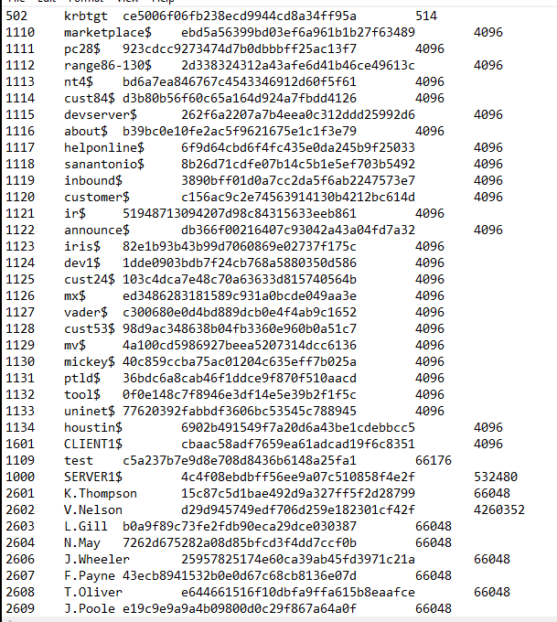

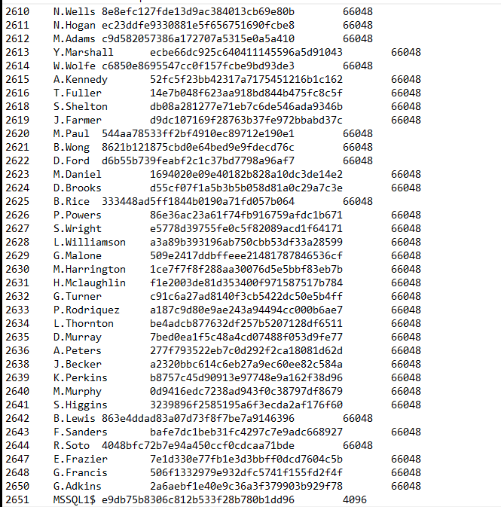

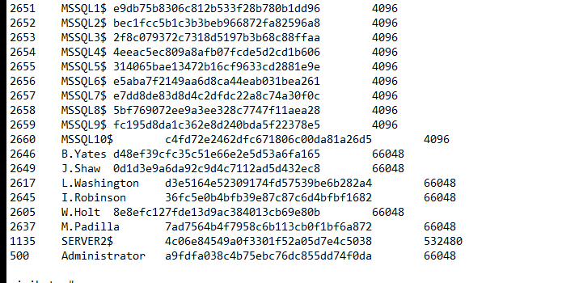

Figure 20-1: Output from the lsadump command

## Appendix C – Other Data

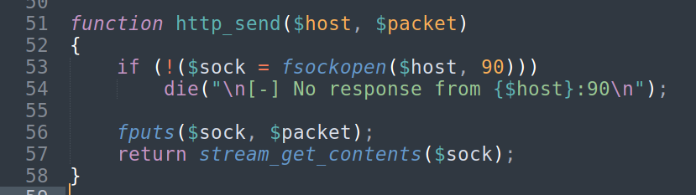

Figure 15: Altered exploit code to work with the webserver on a different port

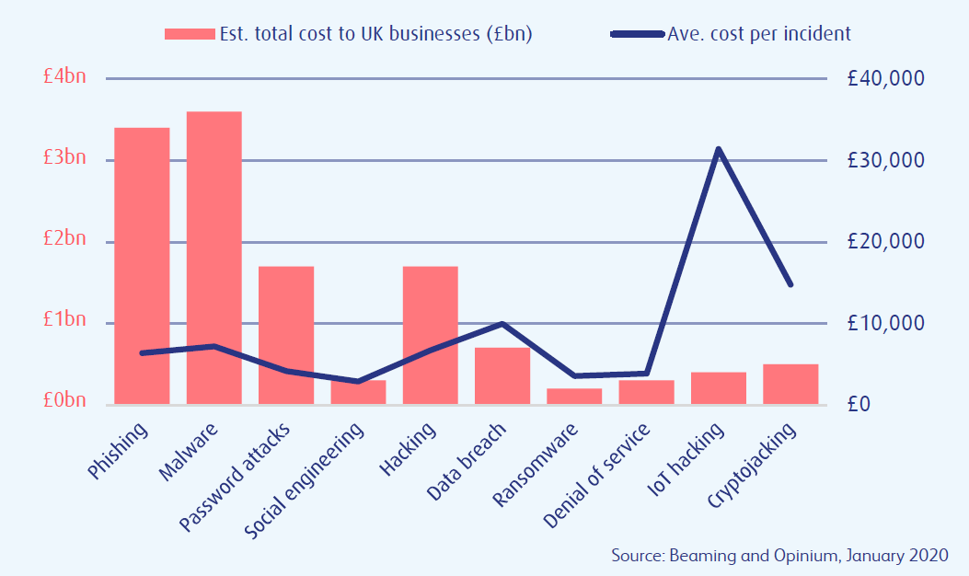

Figure 32: Graph showing the total cost of various cyber attacks on UK businesses in 2019

|  |  |  |
| --- | --- | --- |
| **Username** | **Hash** | **Password** |
| test | c5a237b7e9d8e708d8436b6148a25fa1 | test123 |
| V.Nelson | d29d945749edf706d259e182301cf42f | dropper |
| N.Wells | 8e8efc127fde13d9ac384013cb69e80b | caprice |
| M.Adams | c9d582057386a172707a5315e0a5a410 | eavesdropper |
| W.Wolfe | c6850e8695547cc0f157fcbe9bd93de3 | pudding |
| J.Farmer | d9dc107169f28763b37fe972bbabd37c | Princeton |
| S.Wright | e5778d39755fe0c5f82089acd1f64171 | snapshot |
| L.Williamson | a3a89b393196ab750cbb53df33a28599 | planetoid |
| H.Mclaughlin | f1e2003de81d353400f971587517b784 | saxophone |
| S.Higgins | 3239896f2585195a6f3ecda2af176f60 | bungalow |
| G.Francis | 506f1332979e932dfc5741f155fd2f4f | degenerate |
| G.Adkins | 2a6aebf1e40e9c36a3f379903b929f78 | vaginal |
| Administrator | a9fdfa038c4b75ebc76dc855dd74f0da | password123 |
| M.Padilla | 7ad7564b4f7958c6b113cb0f1bf6a872 | Pervasive |
| L.Washington | d3e5164e52309174fd57539be6b282a4 | calculus |

Table 1: Table of usernames, hashed passwords and their plaintext value